The Future of Cities Needs to be First Reimagined
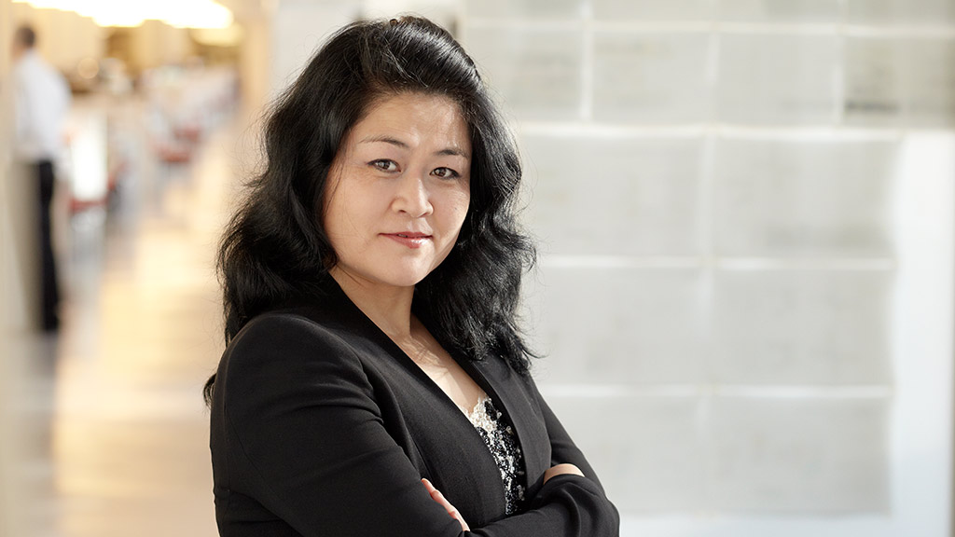
Xiaomei Lee, LEED AP BD+C
Regional Managing Principal
Gensler Greater China

This International Women’s Day, I was honored to be in the company of a group of women professionals at the joint Chamber of Commerce in Shanghai to share and speak on issues facing female leaders today and the unique role we offer in the professional environment. Through the women professional network, we hope to inspire each other, to be role models for each other, and to create a network for sharing and support.

Representing the architecture sector, I have witnessed much changes to this industry. Today, in China and all over the world, more and more we see women designers and women in leadership roles. Gensler, being largest architectural design firm in the world in global footprint and employees, sees diversity is an important part of our culture. We are proud of our gender diversity across all roles in our leadership.

My career as an architect started in the late 1990s. As a young student of architecture upon graduation, I felt energized with the prospect of entering into the architecture and construction sector. China in the late 1990s and early 2000s was marked by a period of rapid private sector growth and fast urban development, creating demand for real estate development. By mid 2010s, China’s urban skyline is defined by skyscrapers and iconic architecture that brought visual identity to each city it belongs.

“Climate action is stepping up in China and across the world”

Today, with real estate development and construction at such a scale, sustainability has become a pressing issue in China and across the world. We need buildings that are sustainable and energy efficient.

Gensler, being the largest architecture firm in the world, is responsible for thousands of acres and volume in development. In response to the growing climate threat, the Gensler Climate Challenge was introduced in 2018 with the aim to work with clients and developers to carefully control carbon emission and over the next 10 years.

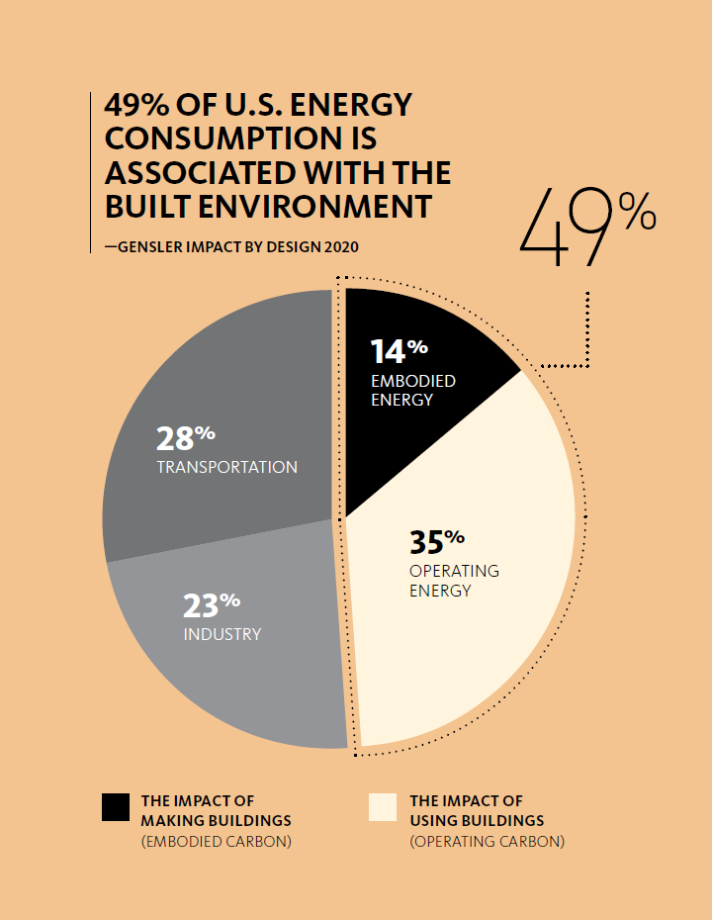
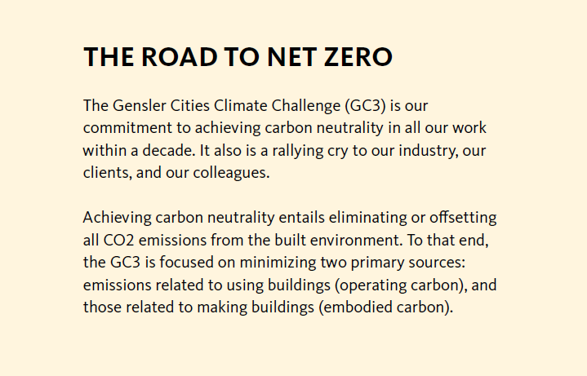
In a study, noteworthy that 49% of U.S. Energy Consumption is associated with the built environment in terms of operational carbon (electricity and Co2 emission) and embodied carbon (building materials).

Climate action needs to be stepped up in China and across the world. At the annual session of the National People's Congress in March 2021, the Government announced plans for China to reduce energy consumption by 13.5 percent and carbon dioxide emissions by 18 percent, both by unit of GDP, over the next five years that is outlined in the 14th Five-Year plan. This is part of China’s pledge in 2016 at the Paris Agreement for carbon emissions to peak by 2030 and to achieve carbon neutrality by 2060.

Planet Earth is 10 years away from irreversible damage to the climate. Addressing Climate Change is the moral and business imperatives of our time, and Gensler is committed to working with developers to promoting sustainable development. In our new publication Climate Change Through Design, the document provides strategies and discussions on how design can transform the built environment for a net-zero future – strategies that includes choice of construction materials, building’s adaptive reuse, cost effective energy efficiency paired with renewable technologies, etc.

“Design Strategies for a Post-Pandemic World”
All over the world, we are still grappling with the pandemic. There is now a refocus on personal health and wellness, as well as attention to our living space and work environment – in the office, restaurants, airports, schools and public parks etc.

Since the start of the pandemic, Gensler has been helping developers and clients on counter strategies. In our latest publication Design Forecast 2021, we provided a collection of thought leadership in design to provide immediate actionable solutions and help people reimagines the future they need.

Our designers push the boundaries to find design solution for a more energy efficient building and a more human approach to urban development, because architects are creating the spaces that we live for the future.

“Policies That Will Further Shape Urban Development in China”

As architects, not only do we approach the design of a building one at a time, we need to keep abreast with government policies and economic trends that shape the future of cities. Not only will it forecast where business opportunities for the built environment will grow, but also to have a wider perspective of the city’s top-level design, and in which direction its economy will grow.

In the latest Government Report delivered in Beijing, detailing plans for vision 2035, there are a few keywords in particular for architects to takeaway – “Rural Revitalization”, “Urban Renewal”, “Tech & Innovation”, “Integrated Economic Zones” and “Quality of Living”.

China has been set on a course to achieve higher-quality development, to further open up its economy, modernize and improve the quality of life for the people. Revitalization of rural areas will mean increased develop of infrastructure and investment in public facilities, potentially creating a big impact on consumption at the county level.

In urban cities, as population continue to expand, urban renewal becomes a necessity. In the next ten years, megacities will be created with the Government plans for clusters of integrated cities (GBA, Yangtze River Delta, Jing-Jin-Ji, etc). Together with the economic opportunities, real estate will further develop in regions along transit lines and transportation hubs in these city clusters.

Increased R&D spending and innovation will point to an economy that will be more acclimated to new technologies, 5G, AI, big data and ecommerce. These trends will no doubt transform businesses –
creating demand for real estate, commercial development, transforming the retail environment, changing the way we work, live and play.

“Best Advice for Young Professions”

Being an architect is to maintain an enthusiasm to learn – to keep our eyes and ears open.

I remember someone once asked me at the recent International Women’s Day event in Shanghai, “As a woman in a position of leadership, do you approach your work differently?” I would say that professionalism and leadership isn’t really defined by gender. And what advice would I share with young women today who wishes to advance their careers in the corporate world? I would say, “Self-confidence is a value that every woman in a position of leadership needs. And finding good role models and mentorship is key”.

Xiaomei Lee, LEED AP BD+C
Regional Managing Principal
Gensler Greater China

As Co-Regional Managing Principal for the Greater China Region, Xiaomei closely oversees the growth and development of the region. Xiaomei has more than 25 years of experience and has directed projects of diverse and complex scale from master planning and tall building architecture, to corporate campus and workplace interiors. Her client-centric approach and deep understanding of local context, paired with broad knowledge of international standards of delivery has been instrumental in the growth of our Greater China practice, and in shaping the Shanghai hub office as a design innovation center. She was Gensler’s Board of Director and serves on Management Committee and has been deeply involved in advancing Gensler’s research and innovations, including acting as the project director for the 632-meter-high Shanghai Tower, China’s tallest building. She is a member of the Council on Tall Buildings and Urban Habitat (CTBUH) and has been a keynote speaker and panelist at their many conferences, including her latest involvement as a jury member at the CTBUH 2019 Tall + Urban Innovation Global Award. Xiaomei is a global trustee of the Urban Land Institute (ULI). In addition, she is the Vice Chairwoman of the Council on International Exchange Affairs of Tall Buildings of the Architectural Society of China and chairperson of the Women Executive Network at AmCham Shanghai.

