Asia and the Pacific poised to become a significant actor in both established and emerging space business

The current state of the global space economy is valued at a third of USD 1 Trillion. Morgan Stanley estimate that number may reach USD 1.1 Trillion by 2040, which is consistent with US-based United Launch Alliance projections. Nearly half of that number until 2040 is driven by satellite broadband and Earth observation, whose share may further increase with the rise of data-driven business models. But so far, low and geostationary orbit remain the sole markets with neatly defined paying customers and value chains that warrant investment. While objections remain around e.g. satellite broadband affordability, the overall satellites business case is sound.

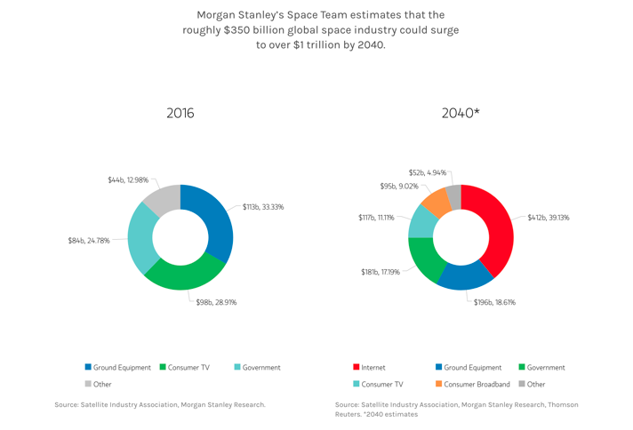
Morgan Stanley’s 2040 vision for the global space economy.
Image credit: Morgan Stanley [https://www.morganstanley.com/Themes/global-space-economy]

However, as you would move toward cislunar space, the Moon, and beyond, skepticism used to be prevalent. Apart from government missions subject to political whims, it seemed like you didn’t have a market, nor a customer, nor a value chain, nor a sound business case. But only expectations, when it comes to space-based solar power generation, resources utilization, manufacturing business, in cislunar space and beyond. And yet private sector investors lately have been flocking toward the domain of new space business investment, all in anticipation of resources-driven sustainable opportunities in a high-risk high-return environment. While that conversation used to be US/EU-centric, with a role for special jurisdictions such as Luxembourg, and now the UAE, it turns out Asia and the Pacific are on a trajectory to claim a lion share of the new space business action.

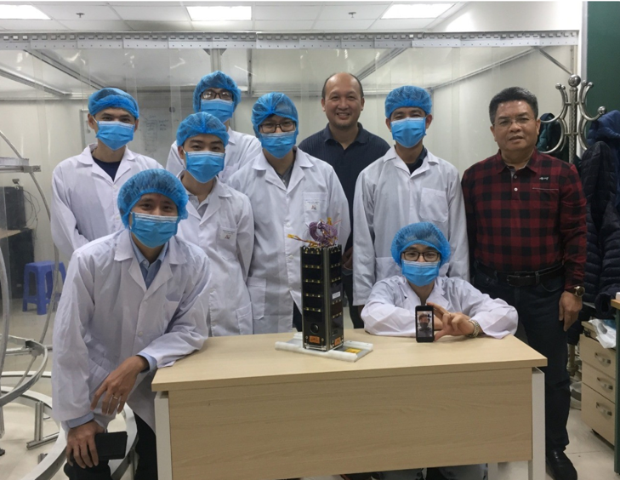

The VNSC team that built the NanoDragon satellite prior to its successful final test.
Picture credit: VNSC [https://vnsc.org.vn/]

Asia and the Pacific are home to established national space powers starting with China, South-Korea, Japan, and Australia, which have ‘skin in the game’ in vigorous domestic new space start-up scenes. New Zealand only set up its space agency back in 2016, yet with Rocket Lab’s establishment of its Launch Complex 1 commercial spaceport, it is now the first country to welcome and operate a fully private orbital launch facility. Meanwhile, Malaysia has launched its own Space Initiative. Indonesia has an agency and developed its own National Space Law, to participate into the launching and Earth observation data value chain, while building up science and technology capabilities. The Philippines, Thailand, Cambodia, have made moves in new space. In March 2021, Vietnam-made micro-satellite NanoDragon, developed and built by the Vietnam National Space Center (VNSC) engineers, went successfully through its final tests in Japan, and is now ready for launching. As for Singapore, with its overall significant business, legal, tech, and financial clout, on top of a foray in new space activities, it would clearly benefit from the establishment of a government driven strategy and of a Singapore space agency.

A recent report SPACETIDE COMPASS Vol.4 (2021) issued by the Tokyo-based SPACETIDE Foundation, estimated that 54 new space domestic startups are currently active in Japan, while the number is 204 for all new space start-ups in Asia outside Japan. The amount of capital raised by start-ups in Japan for 2020 stood at about USD 100 millions, a less than 40% decrease compared with 2019 pre-pandemic numbers at USD 160 million, in a sector set to rebound strongly. Furthermore, the report identifies 92 ‘down-to-Earth’ companies in Japan across all manufacturing and services sectors, that are involved in the larger emerging new space value chain.

As it turns out, institutions and businesses in Asia and the Pacific are particularly well positioned to develop new Earth observation data value-chain models, as more providers and datasets appear that generate solutions, being stimulated by a vigorous Asian business, legal, tech and financial community demand for data-driven business, risk management, and investment decision models. With next decades timelines of new space business and digital integration interlinked, space and data will have a direct impact on how families manage their health, lives, education, and wealth, and businesses make better data-driven decisions with financial services providers.

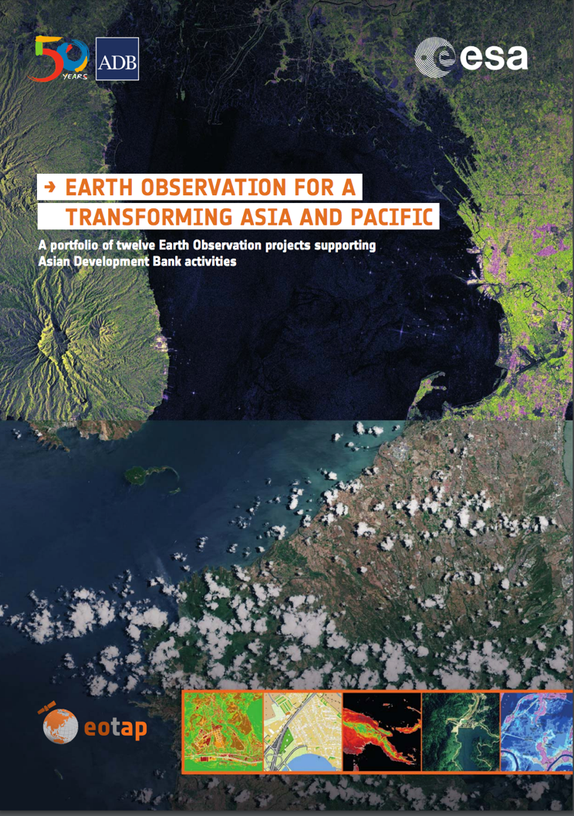
Earth observation for a transforming Asia and Pacific, an Asian Development Bank
project in cooperation with the European Space Agency.
Picture credit: ADB [https://www.adb.org/]

A key challenge for new space is to slice it down to business cases that may be invested within timelines that are compatible with funding structures and individual longevity and expectations, as investors require commercially credible, financially sustainable, legally implementable value propositions. 2010 founded Tokyo-based global company ‘ispace’ is a case in point for that new trend. Among 5 finalists of the Google lunar prize, its business model for Moon mission have attracted hundreds of millions of USD funding. With a lunar resources business case, its short-term revenue model may be space and Moon data driven. With its Luxembourg-based affiliate, the ispace PhD team has developed the Lunar Ore Reserve Standards LORS-101, a tentative new framework strongly inspired by the mining and oil & gas industries resources validation process. Upgrading space laws in the area of property rights, ownership of data sets and operational results, hangs in the balance, to provide investors with predictable investment frameworks for the validation of exploitable lunar and space resources.

Governments and the private sector in Asia and the Pacific have an opportunity to come together to boost their fortunes as national space powers. At Autonomous Space Futures Ltd, we note that, subject to space laws upgrading, Asia and the Pacific are poised for strong, no-nonsense, valid data- and exploration-driven business cases for new space investment, as new ventures have emerged that operate over the full spectrum of space tourism & migration, in-orbit services, space exploration, mining, and lunar & space resources exploitation, including energy & debris recycling.

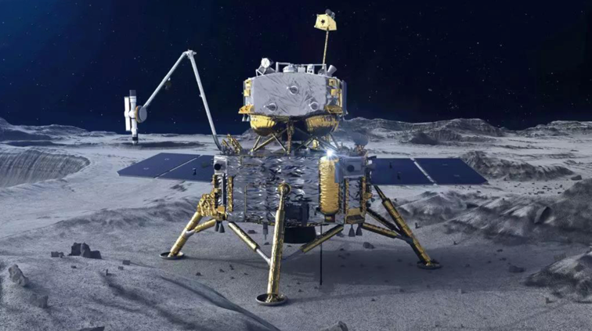
A representation of China's Chang'e-5 in action on the far side of the Moon.
Image credit: CNSA [http://www.cnsa.gov.cn]

China’s success with the Chang'e 5 mission, its Moon base with Russia projected by the 2030’s, are a reminder that, for governments and private sector actors’ activities in space to thrive, they should also be based on the right kind of incentives. And participation into a planetary dialogue based on consensus, mutual respect, and understanding, to build a better legal system and much needed space resources and business coordination mechanisms. That allows the whole of humanity and the next generations an opportunity for peaceful and sustainable socio-economic development, on Earth, in orbit, on the Moon, on Mars, and beyond.

The sky is no longer the limit.

